|  |
| --- |
|  |
|  |

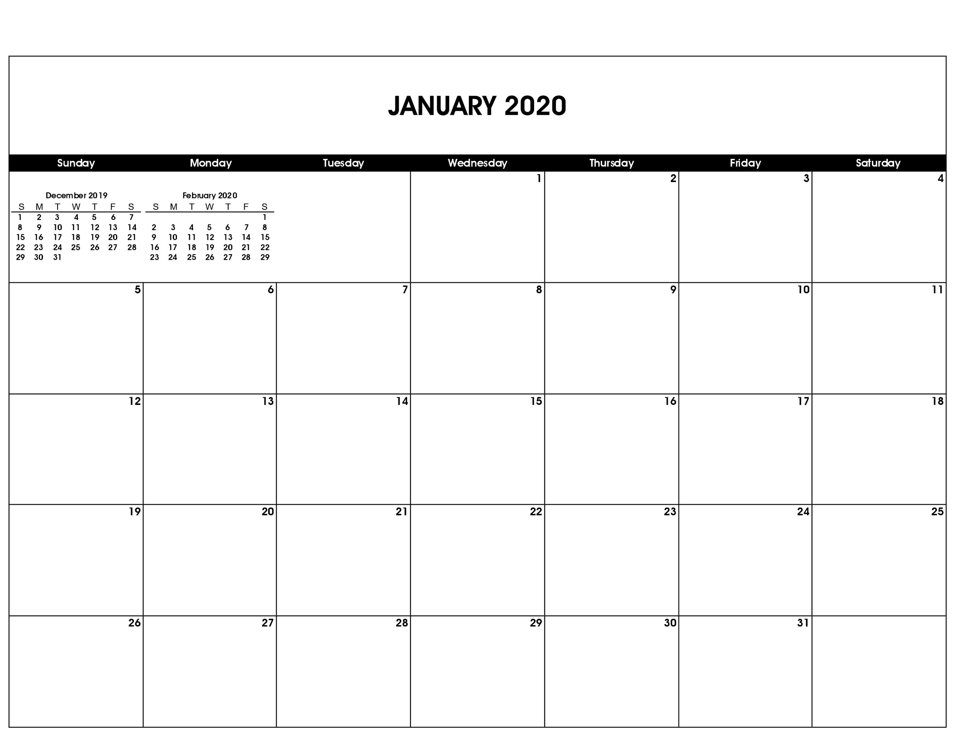

New Year’s Day

Martin Luther King Jr. Day

|  |
| --- |
|  |

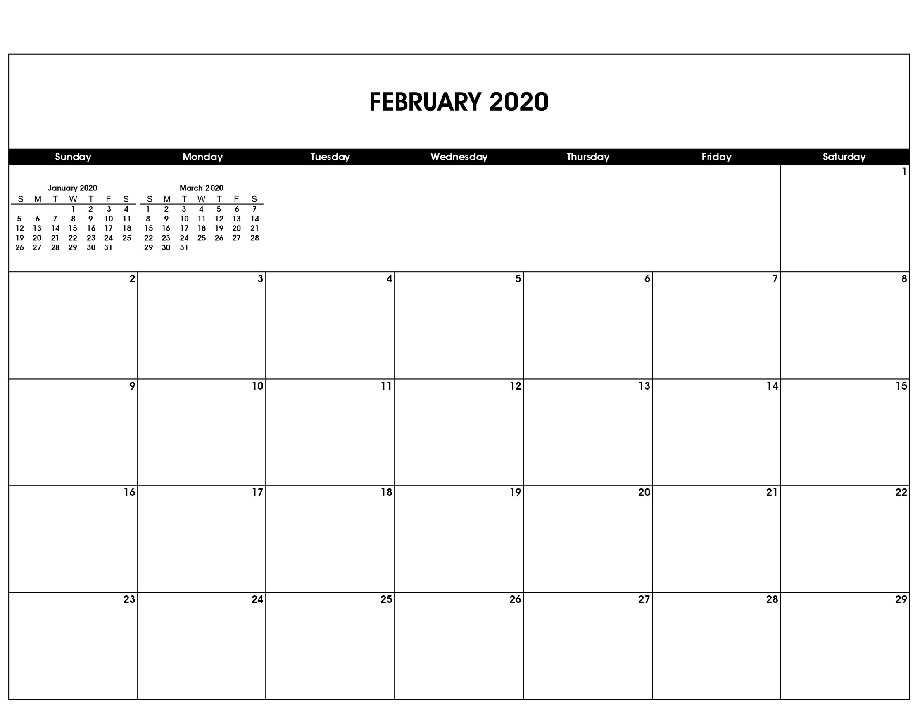

Presidents Day

Valentine’s Day

|  |
| --- |
|  |

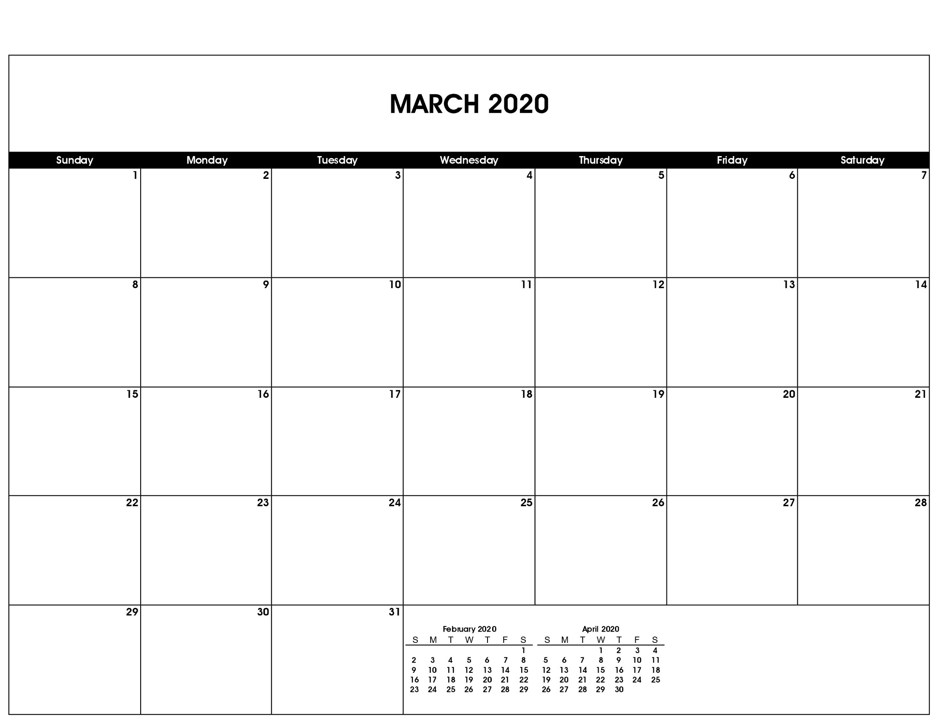

Daylight Saving Time Begins

St. Patrick’s Day

First Day of Spring

|  |
| --- |
|  |

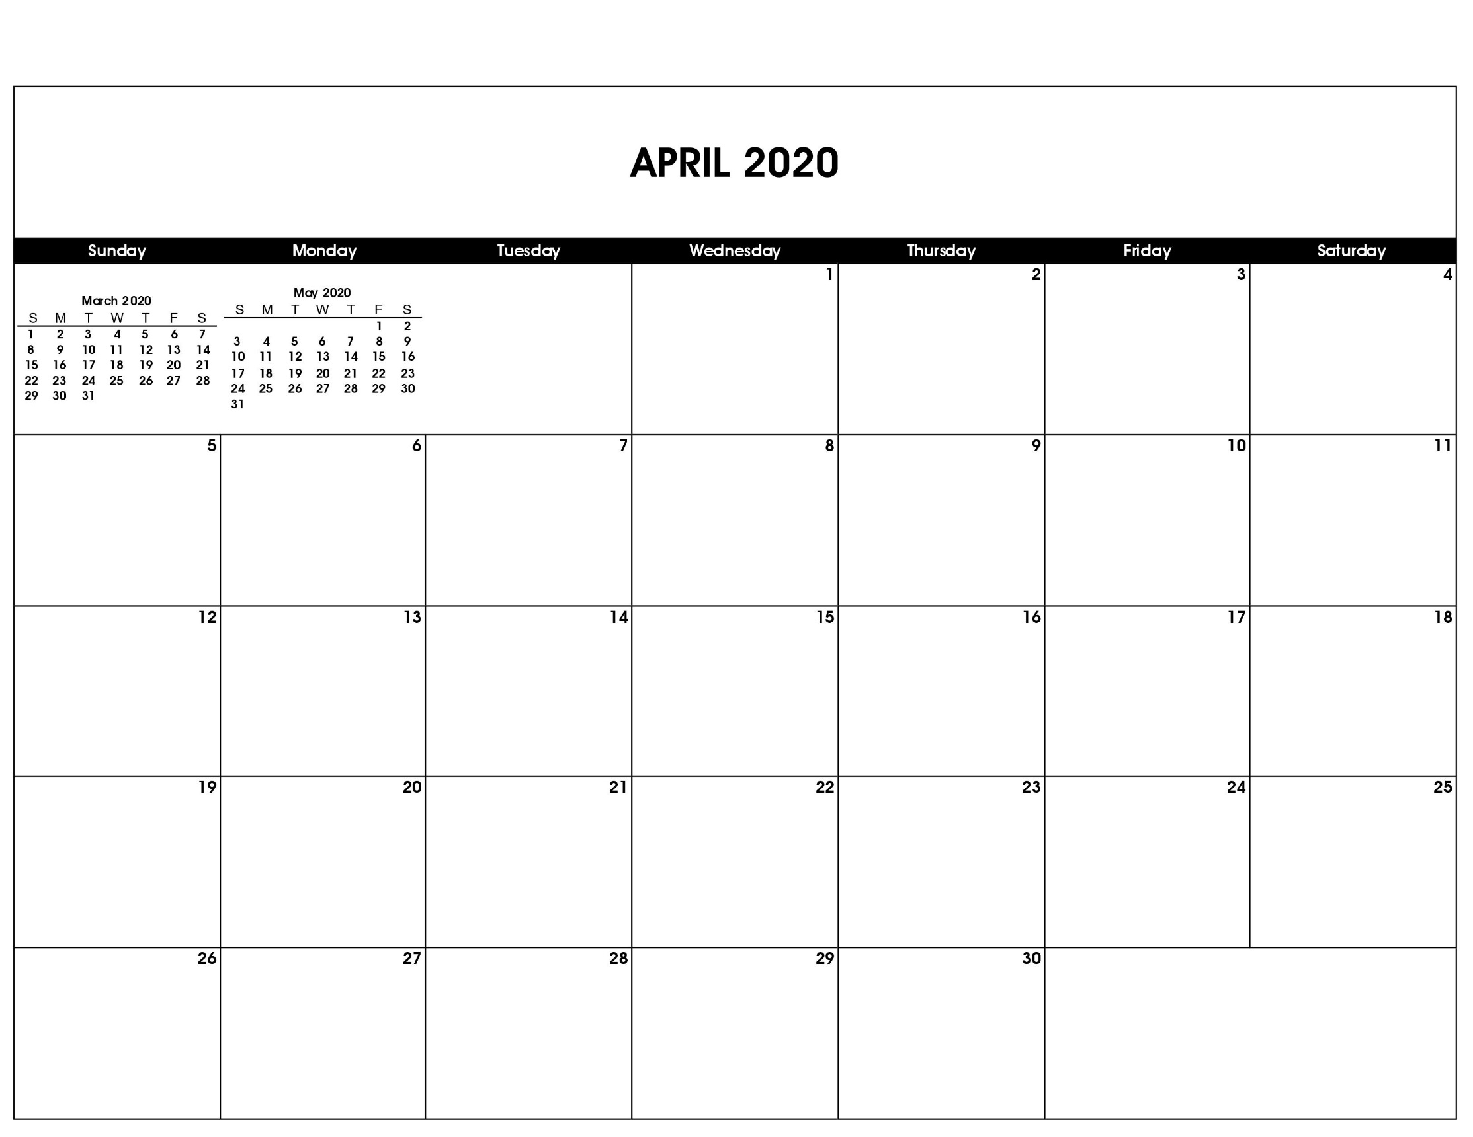

Easter

Good Friday

Passover Begins

Last Day of Passover

Arbor Day

|  |
| --- |
|  |

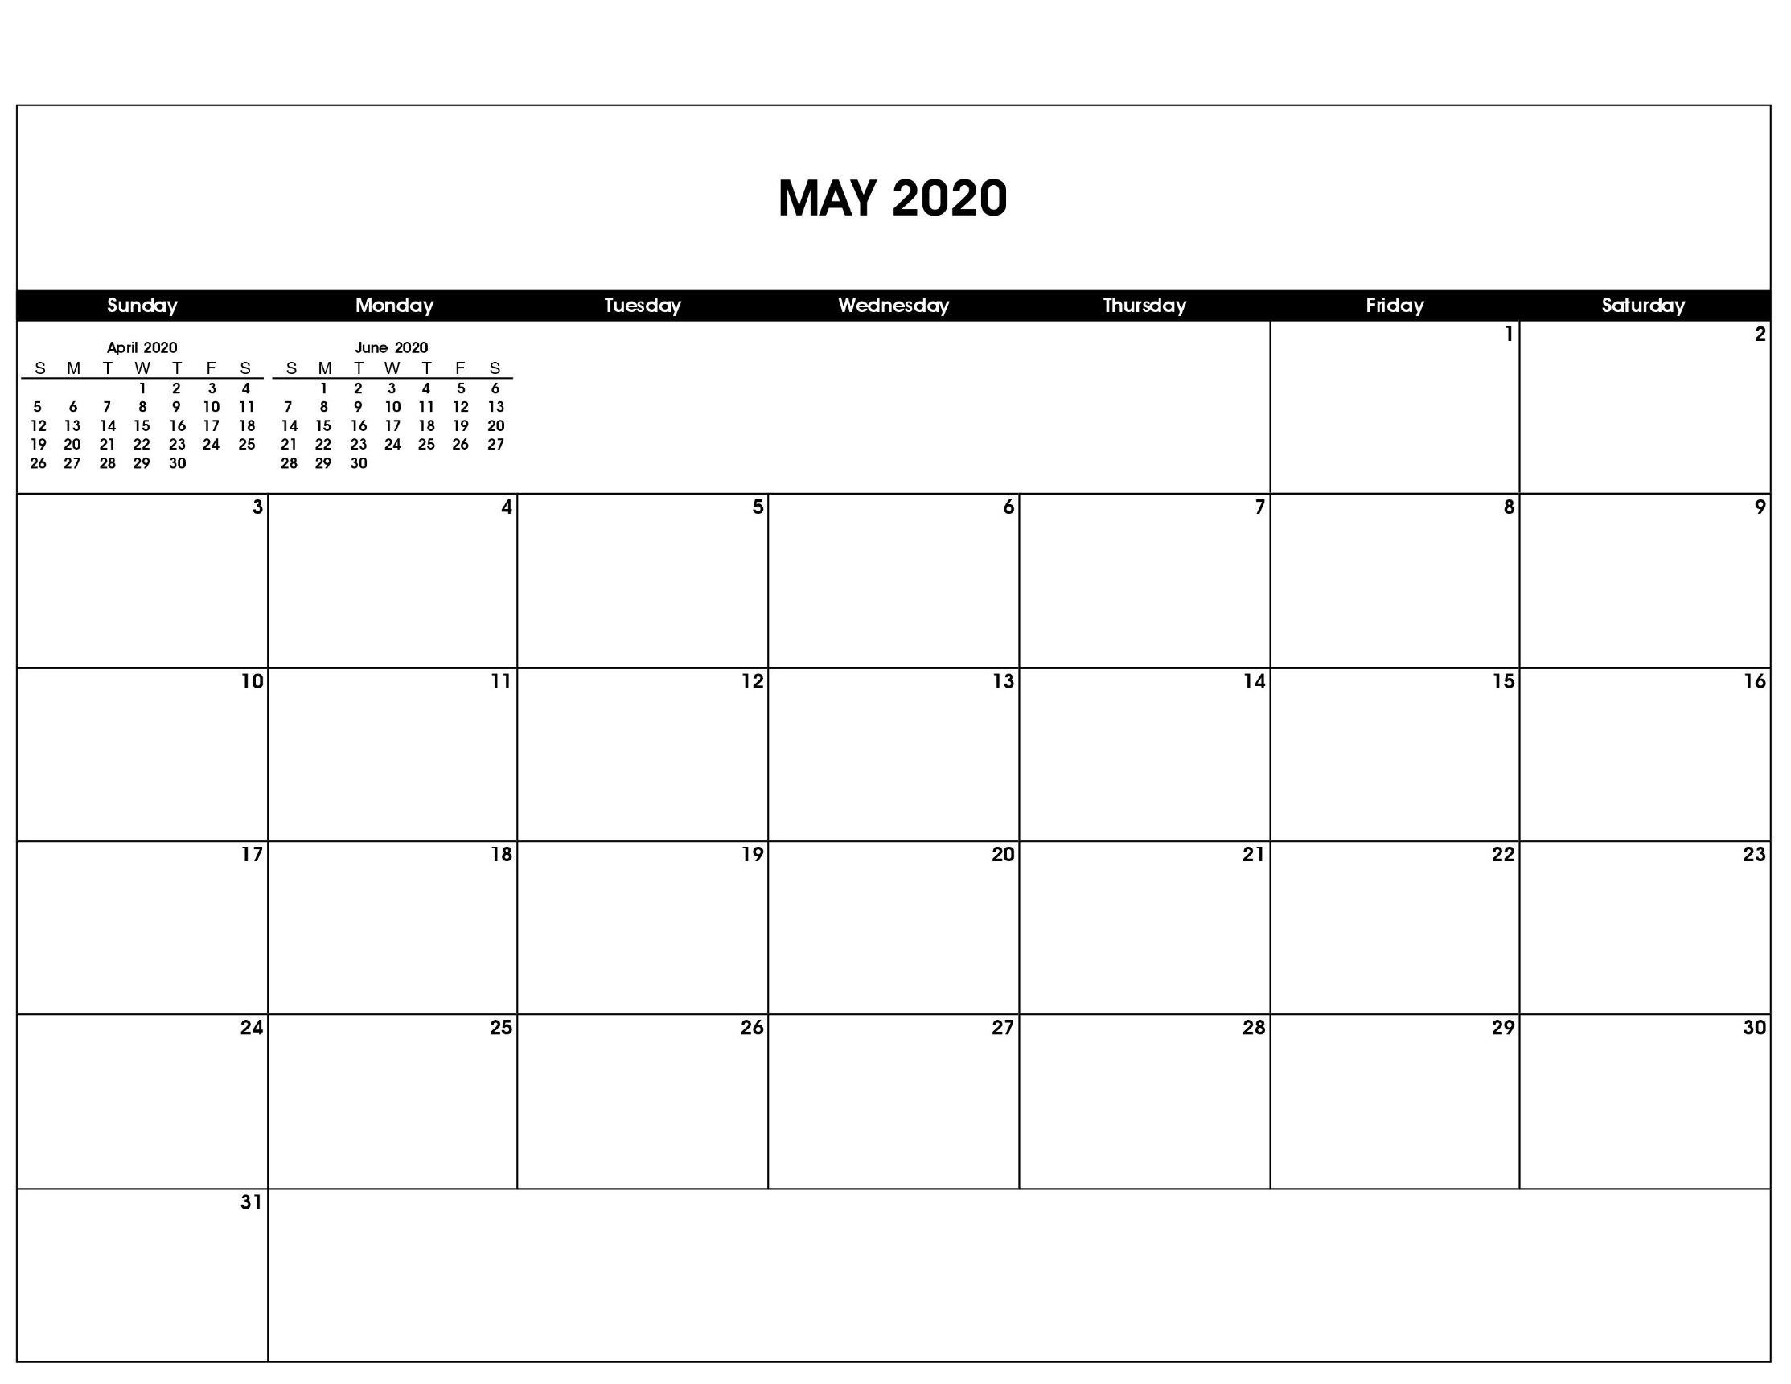

Mother’s Day

Cinco de Mayo

Memorial Day

|  |
| --- |
|  |

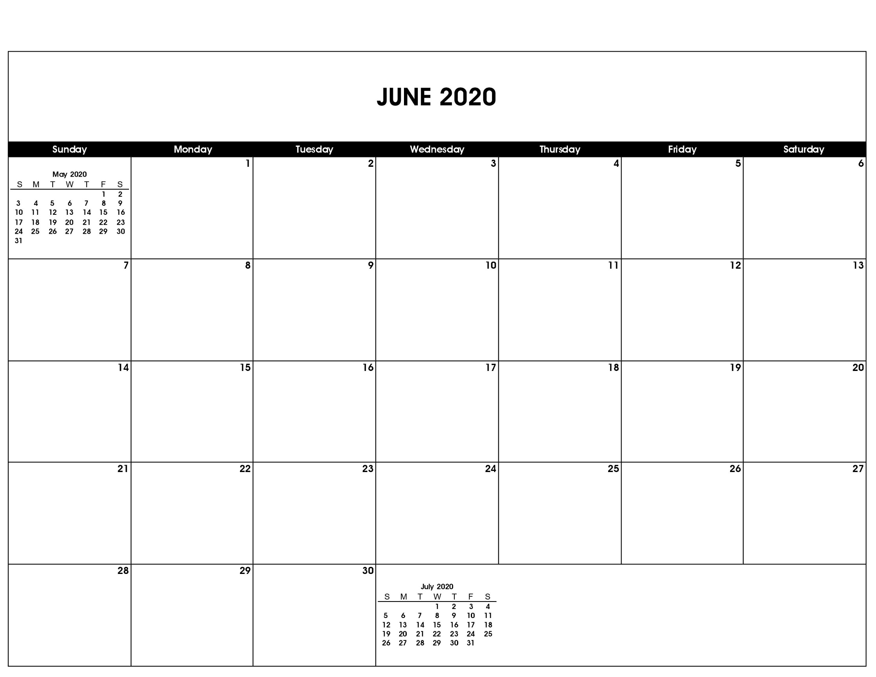

Father’s Day

First Day of Summer

|  |
| --- |
|  |

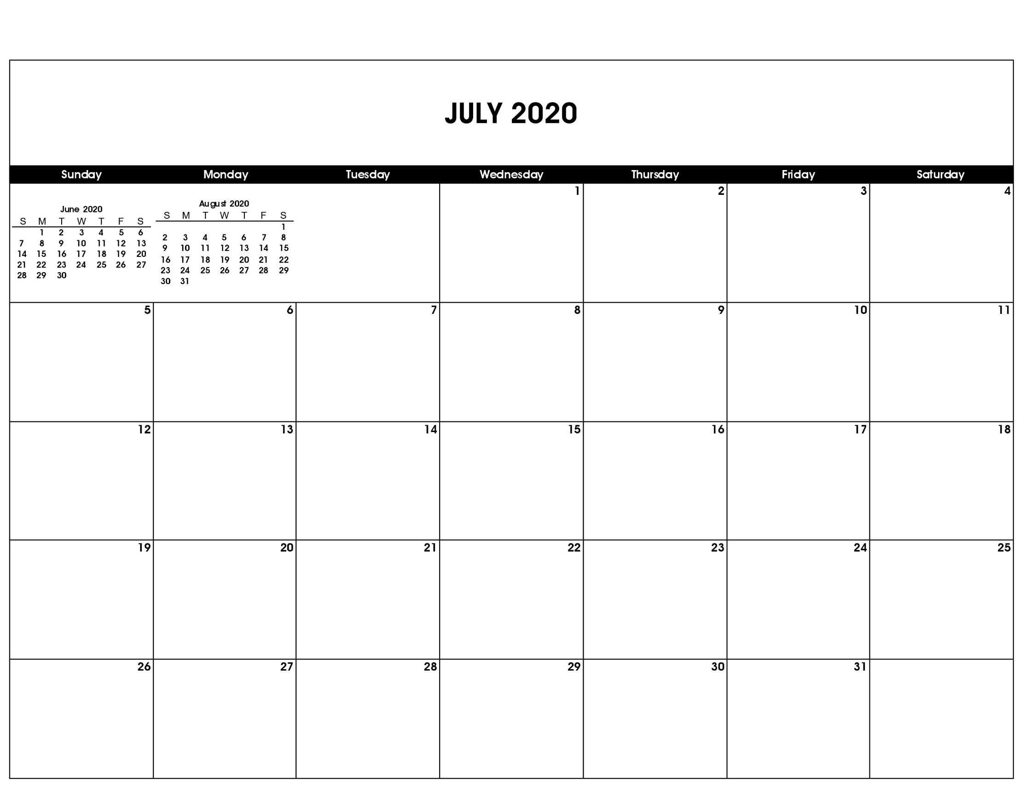

Independence Day

Independence Day (Observed)

|  |
| --- |
|  |

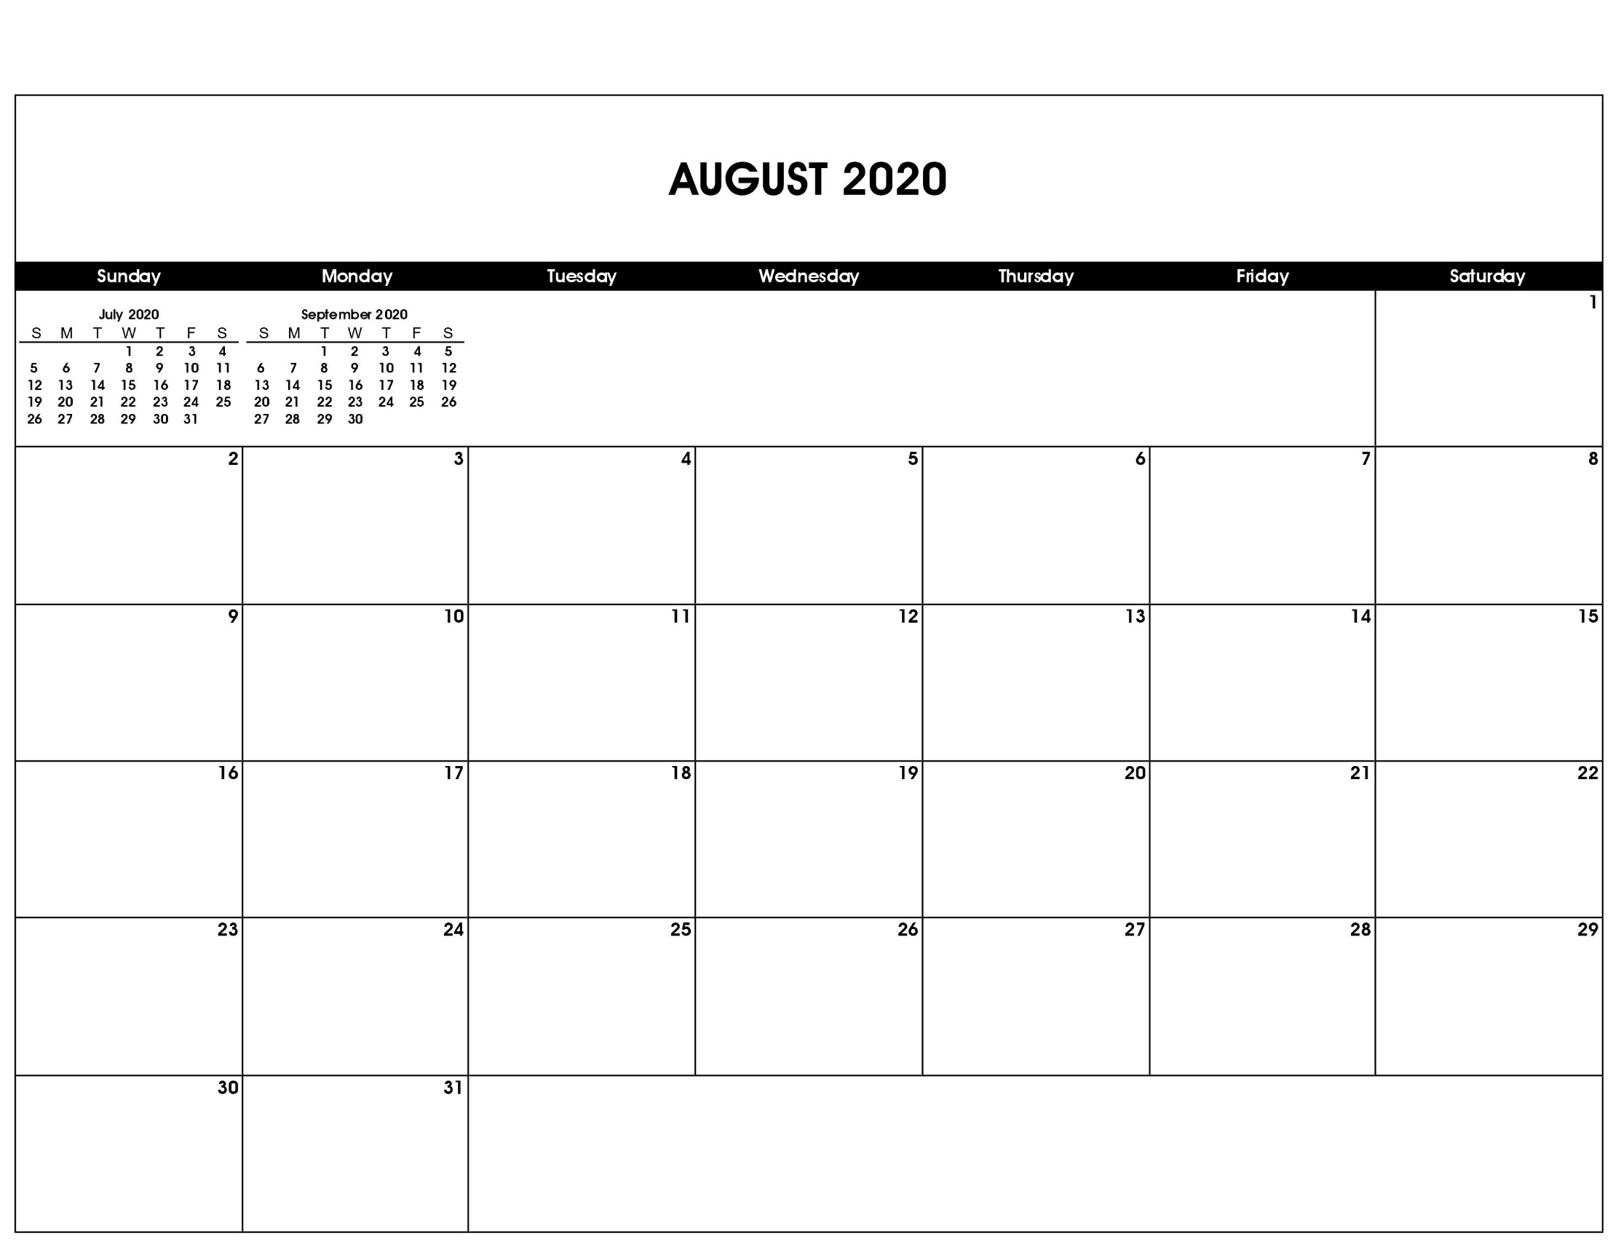

|  |
| --- |
|  |

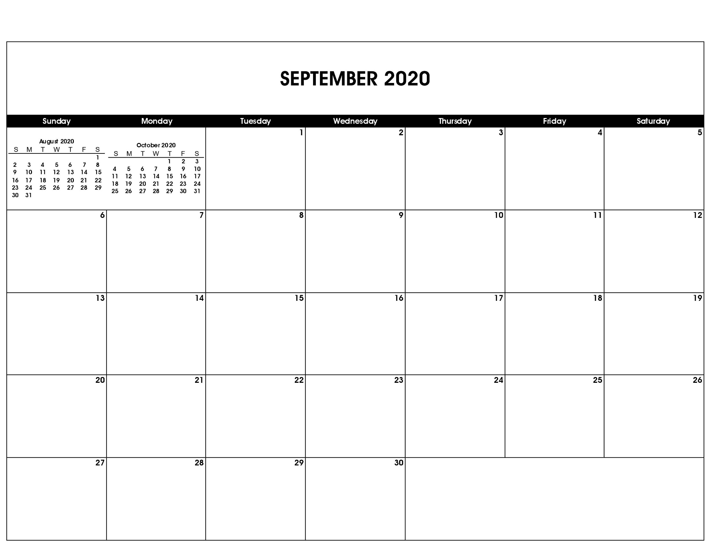

Labor Day

Patriot Day

Grandparents Day

Yom Kippur

Rosh Hashana

First Day of Autumn

|  |
| --- |
|  |

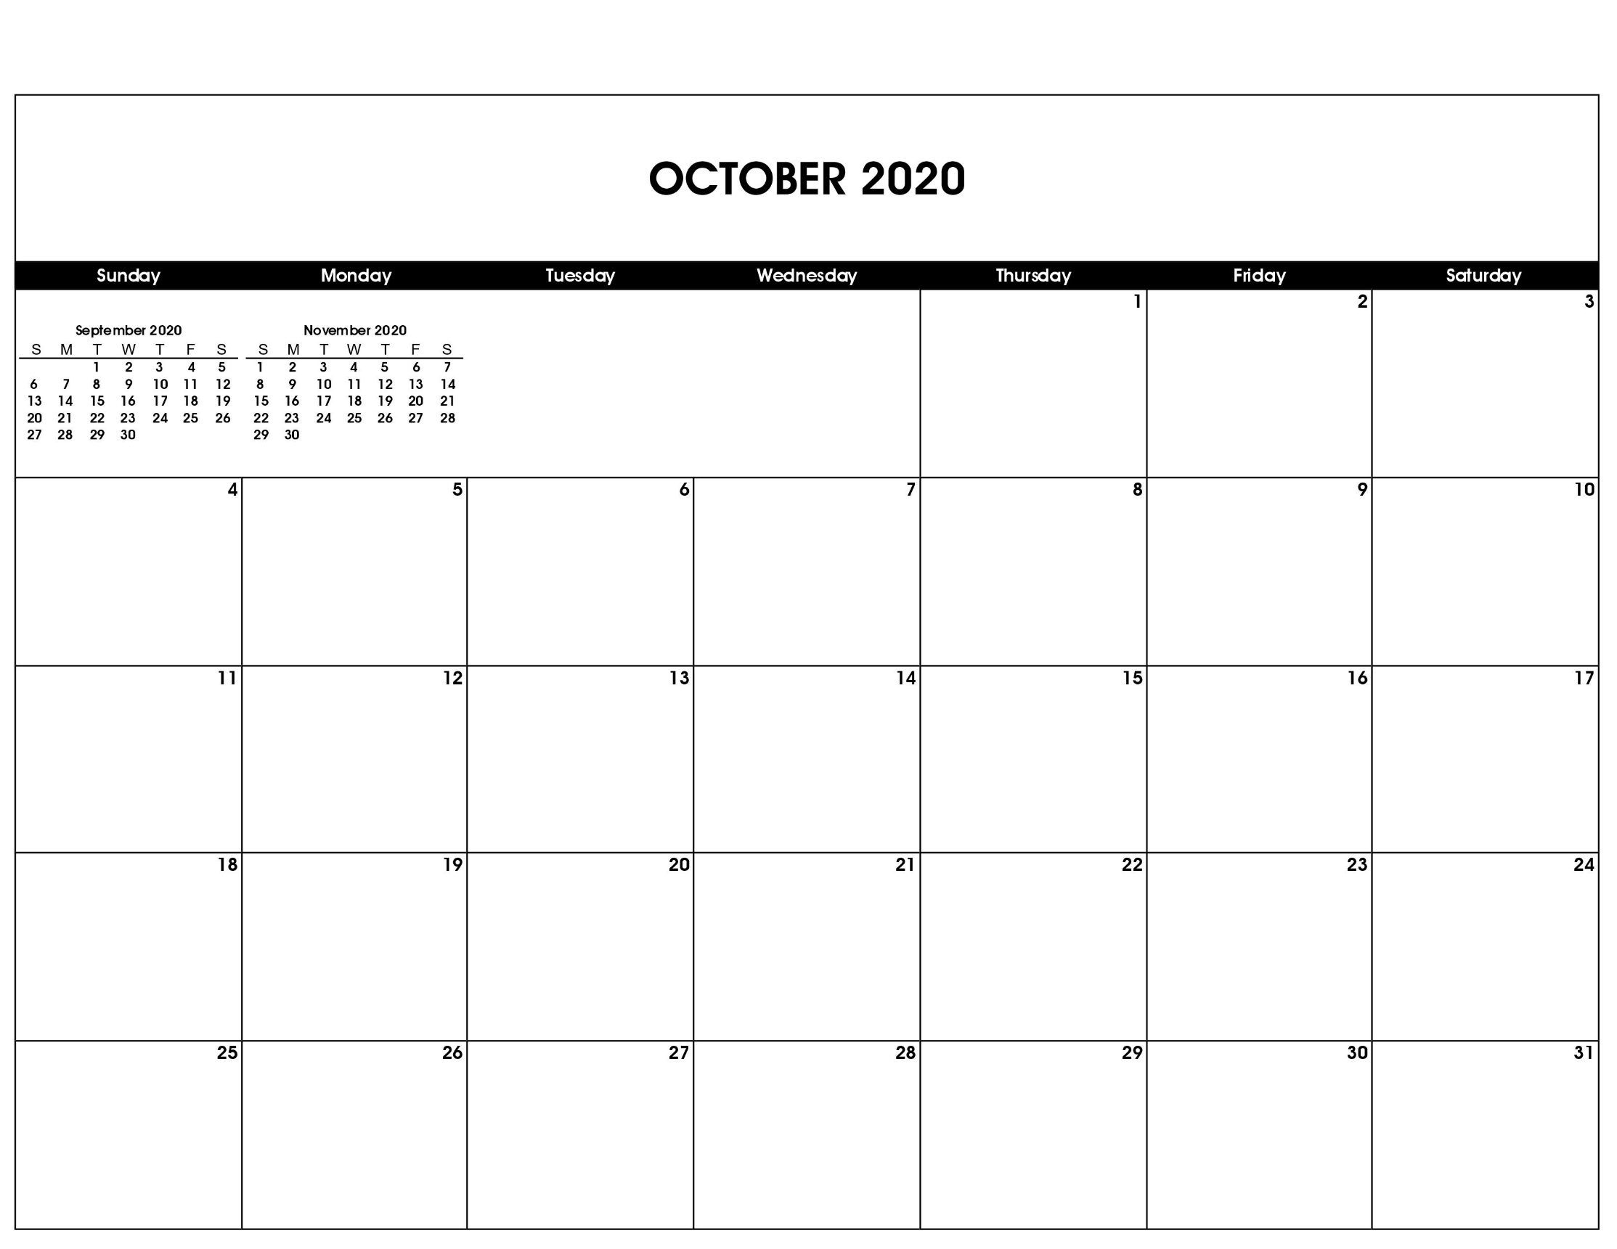

Halloween

Columbus Day

|  |
| --- |
|  |

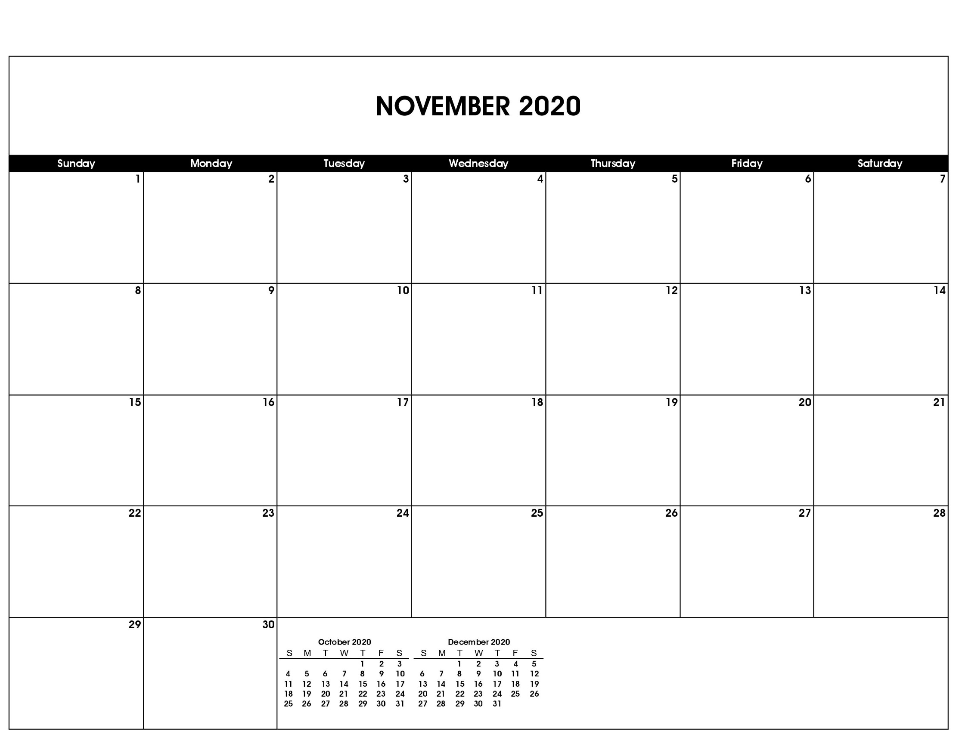

Veterans Day

Daylight Savings Time Ends

Thanksgiving Day

Election Day

|  |
| --- |
|  |

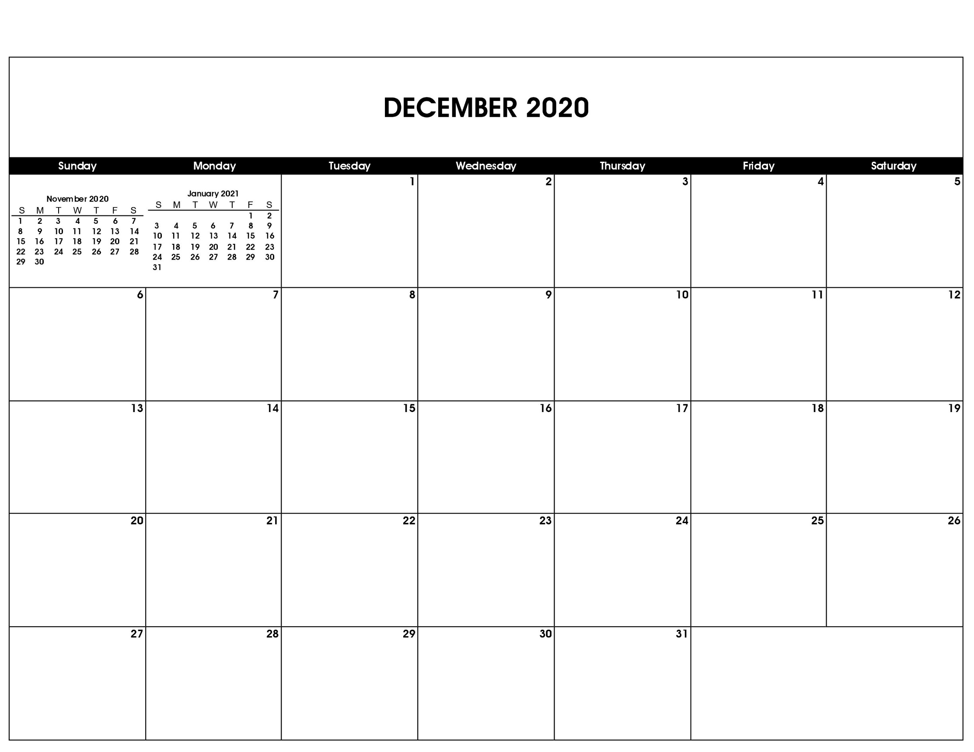

Kwanzaa Begins

First Day of Hanukkah

Christmas Day

New Year’s Eve

First Day of Winter